Preparation of SO₂ gas and study its physical and chemical properties.

Aim:
To study the preparation of Sulphur dioxide gas and its physical and chemical properties.
Variables:
Drag and drop a round bottom flask on R.B stand
Apparatus:
A round bottom flask, a thistle funnel, a delivery tube, a double bored cork, measuring cylinder, R.B. stand and spatula, a wire gauze, a tripod stand, watch glass, Glass dropper bottle, Measuring Cylinder.
Chemicals:
Copper turnings, conc. sulphuric acid.
Procedure:
- Drag the spatula to take few pieces of copper turnings and drop it into round bottom flask.
- Drag a double bored cork and drop it into the mouth of the round bottom flask.
- Drag the thistle funnel and drop it into one of the holes in the cork.
- Drag the delivery tube and drop it into the second hole of the cork and connect other side of the delivery tube to the gas jar.
- Drag the dropper to take 15-20 mL conc. sulphuric acid from glass dropper bottle and drop to measuring cylinder.
- Drag and drop measuring cylinder containing 15 - 20 mL of conc. sulphuric acid to round bottom flask through the thistle funnel.
- Click on the burner to heat the contents.
- Show a colourless gas coming out of the round bottom flask and collect it in the gas jar.
- Shows observation in an icon ‘SO₂ gas is formed inside gas jar’.
- Show a “Next page” button
- Click on the "Next page" button to study its physical and chemical properties.
- Refer figure 1

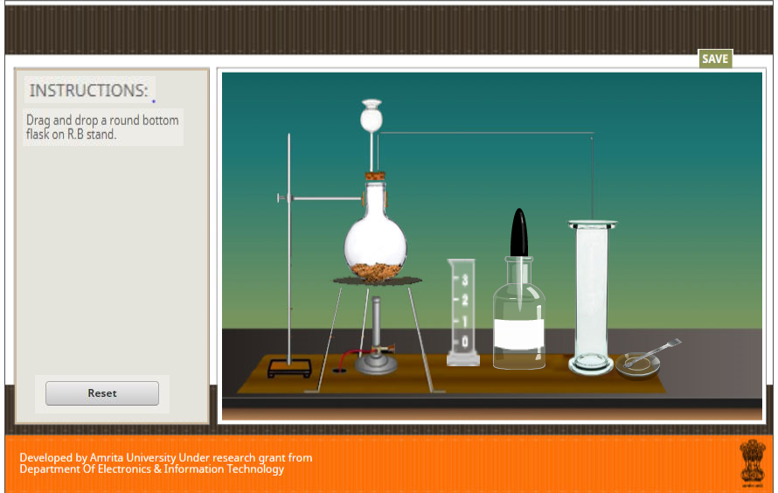
Figure 1

Procedure
Select the physical property from the list.

- Physical properties
  - Colour
1.show the inference message "SO₂ is colourless."
b) Solubility in water
Apparatus: A round bottom flask, a thistle funnel, a delivery tube, a double bored cork, R.B. stand, a trough, a piece of cardboard as a lid.

Procedure:
- Drag a lid on the top of the gas jar containing sulphur dioxide.
- Drag to invert the gas jar and drop it onto the trough containing water.
- Click to remove the lid from gas jar.
- Shows observation in an icon ‘SO₂ gas is soluble in water’
- Refer figure 2
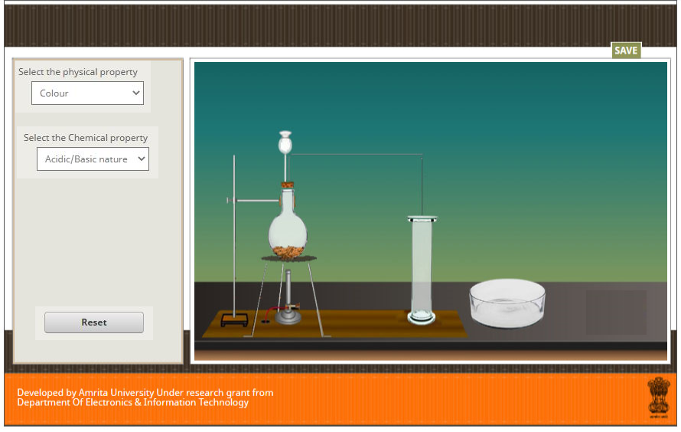
Figure 2
- Chemical properties

- Acidic or basic nature

Apparatus: A round bottom flask, a thistle funnel, a delivery tube, a double bored cork, R.B. stand, red and blue litmus papers.

Procedure:
1.Drag and drop wet red litmus paper to the jar filled with sulphur dioxide.
2.Shows no change in red litmus paper.
3.Drag and drop wet blue litmus paper to the jar filled with sulpher dioxide.
4.Shows blue litmus changes to red.
5. Shows observation in an icon “SO₂ dissolves in water to form sulphurous acid due to which it possesses an acidic character.”
6.Refer figure 3
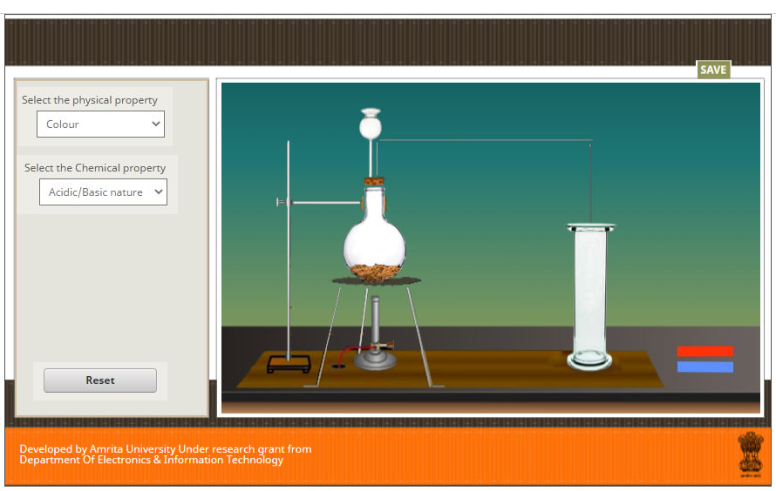
Figure 3

B) Reaction with potassium permanganate solution

Apparatus: A round bottom flask, a thistle funnel, a delivery tube, a double bored cork, R.B. stand,test tube
Chemicals: potassium permanganate solution, diluted H₂SO₄, sulphur dioxide gas.

Procedure:
1.Drag and drop 2 mL of potassium permanganate solution (Purple solution) in a test-tube.
2. Drag and drop 1 mL of diluted H2SO4 in test tube.
3.Drag and drop glasstube to testtube and round bottom flask
4.Turn on burner
5.Turn off burner.
6.The purple colour of the potassium permanganate changes to colourless when SO2 gas is passed.
7.Show an information “Sulphur dioxide being a strong reducing agent, reduces the purple coloured solution to form a colourless solution”.
C) Reaction with potassium dichromate solution
Apparatus: Test tube
Chemicals: potassium dichromate solution (Transparent Orange solution), H2SO4
Procedure:
1. Drag and drop 2ml of acidified potassium dichromate solution into a test tube
2.Drag and drop 1ml of H2SO4 into it.
3.Drag and drop glasstube to testtube and round bottom flask
4.Turn on burner
5.Turn off burner.
6. Shows orange colour of the potassium dichromate changes to green.
7. Show an information “ SO2​+K2​Cr2​O7​+3H2​SO4​→K2​SO4​+Cr2​(SO4​)3​+3H2​O”
8.Refer figure 4

Figure 4

